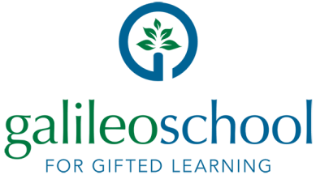

3900 East State Road 46
Sanford, FL 32771

Galileo School Advisory Board Members 2021-22

Mr. Stephen Schenck, Owner Spinnaker Technology, Inc, Former Deputy Mayor, City of Oviedo, and Galileo Founding Board Member
Dr. Taylar Wenzel, Associate Lecturer and Academic Program Coordinator, Elementary Education, UCF
Dr. Mary Little, Professor and Program Coordinator, Exceptional Student Education, UCF
Dr. Elizabeth Dooley, Professor, School of Teacher Education, UCF
Dr. Jeanette Garcia, Assistant Professor, Department of Health Sciences, UCF
Ms. Nancy Brasel, Senior Instructor, Early Childhood Development and Education, UCF
Ms. Nancy Chrisman, President and Founder, Emergent Foundation, Inc. and Emergent Consulting 121.
Dr. Derek Cavilla, Head of School, Futures Academy in Walnut Creek, CA., and former Galileo Director of Curriculum and Instruction

